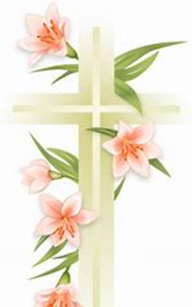
HOLY THURSDAY, April 2nd
7:00pm Mass of The Lord’s Supper
Adoration to 12:00am Midnight

GOOD FRIDAY, April 3rd
Start of Divine Mercy Novena at 2:30pm
3:00pm Celebration of the Passion of the Lord
7:00pm Stations of the Cross
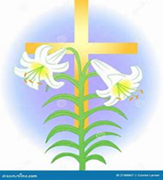
HOLY SATURDAY, April 4th
2:30pm Blessing of Easter Food
2:45pm Divine Mercy Novena
8:00pm Easter Vigil
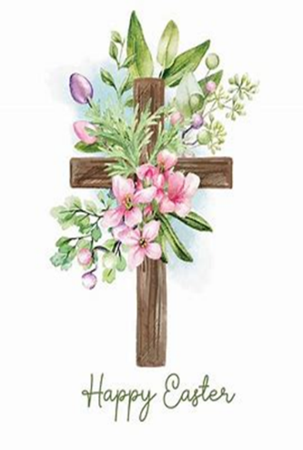

EASTER SUNDAY, April 5th
9:00am, 11:00am
Divine Mercy Novena before both masses
Please note: no 6:15pm mass on Easter Sunday night

DIVINE MERCY SUNDAY - April 12th
3:00pm Holy Hour

