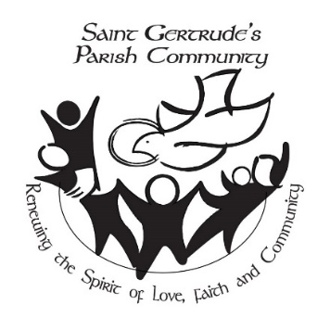

***St Gertrude’s “Drive the Spirit”***

**GOLF TOURNAMENT – TEAM SCRAMBLE**

**REGISTRATION FORM**

|  |  |
| --- | --- |
| **Date: Thursday July 3, 2025**  **Registration:** 12:30 pm  **Shotgun start:** 1:30 pm  **Dinner:** 6:00 pm | **Location:** Harmony Creek Golf Centre  1000 Bloor Street East  Oshawa, Ontario |

***SIGN ME UP! Early Bird:*** $110 Golf & Dinner $60 Dinner only

***After June 8th:*** $130 Golf & Dinner $75 Dinner only

Name:

Email:

*For Golf or Dinner – pair with*:

***PLEASE NOTE –*** *Power Golf Carts are available on a first come, first served basis!****Early Bird*** *rate is $25/person/cart.* ***After******June 4th*** *the rate is $30/person/cart. Power cart fee is payable to ST. GERTRUDE’S with your golf registration. If you want a cart, please complete a CART FORM.*

**I need _______ golf cart(s) I do NOT need a golf cart_______ I’m not sure_______**

**I understand that by buying tickets for the event I agree to hold harmless, release, and forever discharge  St. Gertrude Drive the Spirit from any and all claims, demands, or causes of action arising out of or related to the use of my picture._________ Initial**

**Please *send* Registration Form and Payment to:**

|  |  |
| --- | --- |
| **Beth Cook *OR*** | **St. Gertrude’s** **Parish Office** |
| 131 Auburn Court | 690 King St. East |
| Courtice, Ontario L1E 2E9 | Oshawa, ON L1H 1G5 |
| 905-925-9871 | 905 433 0828 Fax: 905 721 8479 |
| bethcook905@outlook.com | stgertrudesos@archtoronto.org |
| **(Make cheques payable to: St. Gertrude’s Parish)** | |

***DATE: Amount paid: cash cheque***

***Ticket #s delivered:***

**

# **GOLF POWER CART RENTAL AGREEMENT**

**St. Gertrude’s Drive the Spirit Tournament**

**Tournament Date: Thursday, July 3, 2025 18 Holes Cart #:**

**Time Cart Out: Time Cart In:**

The undersigned Lessee hereby agrees to lease the herein described power cart at the price and for the number of holes herein described. The Lessee represents to be familiar with the use and operations of the cart and will keep the cart in the same condition as received subject to ordinary wear and tear and will pay or reimburse Harmony Creek Golf Centre Ltd., the Club or the Lessor, for all damages beyond ordinary wear and tear. The Lessee will be responsible for any damage to the golf cart(s) or golf course property and will be charged for any and all damages to the credit card imprint attached hereto. The Lessee acknowledges receipt of cart in good order and repair. The driver of the power cart must have a G2 or G class driver’s license. Children are not permitted to drive power carts. The Lessee hereby agrees to indemnify and save harmless the Club, Lessor or the employees free from all liabilities or claims whatsoever, no matter how caused, resulting from the use of cart.

Please Print Legibly:

NAME:

ADDRESS:

## City Postal Code

## PHONE: E-MAIL ADDRESS:

CART RETURNED IN SAME CONDITION AS RECEIVED:

Lessee’s Signature Signature of Pro Shop Attendant

**Please note: $10.00 charge for lost or broken key**